**EXPERIMENT 1**

**Aim :**

Introduction to Wireless LAN, Simulator and Digital Communication Trainer System.

**Theory :**

**Wireless LAN –** It is a wireless computer network that links two or more devices using wireless communication to form a local area network (LAN) within a limited area such as a home, school, computer laboratory, campus, or office building. This gives users the ability to move around within the area and remain connected to the network.

Components of Wireless LAN

1. **User Devices –** Users of wireless LANs operate a multitude of devices, such as PCs, laptops, and PDAs. Laptops and PDAs are commonly equipped with wireless LAN connectivity because of their portable nature. User devices might consist of specialized hardware as well.
2. **Radio NICs –** A major part of a wireless LAN includes a radio NIC that operates within the computer device and provides wireless connectivity. It often implements the 802.11 standard. The cards generally implement one particular physical layer.
3. **Access Points –** It contains a radio card that communicates with individual user devices on the wireless LAN, as well as a wired NIC that interfaces to a distribution system, such as Ethernet. System software within the access point bridges together the wireless LAN and distribution sides of the access point. The system software differentiates access points by providing varying degrees of management, installation, and security functions.

802.11 Wireless IEEE Standards

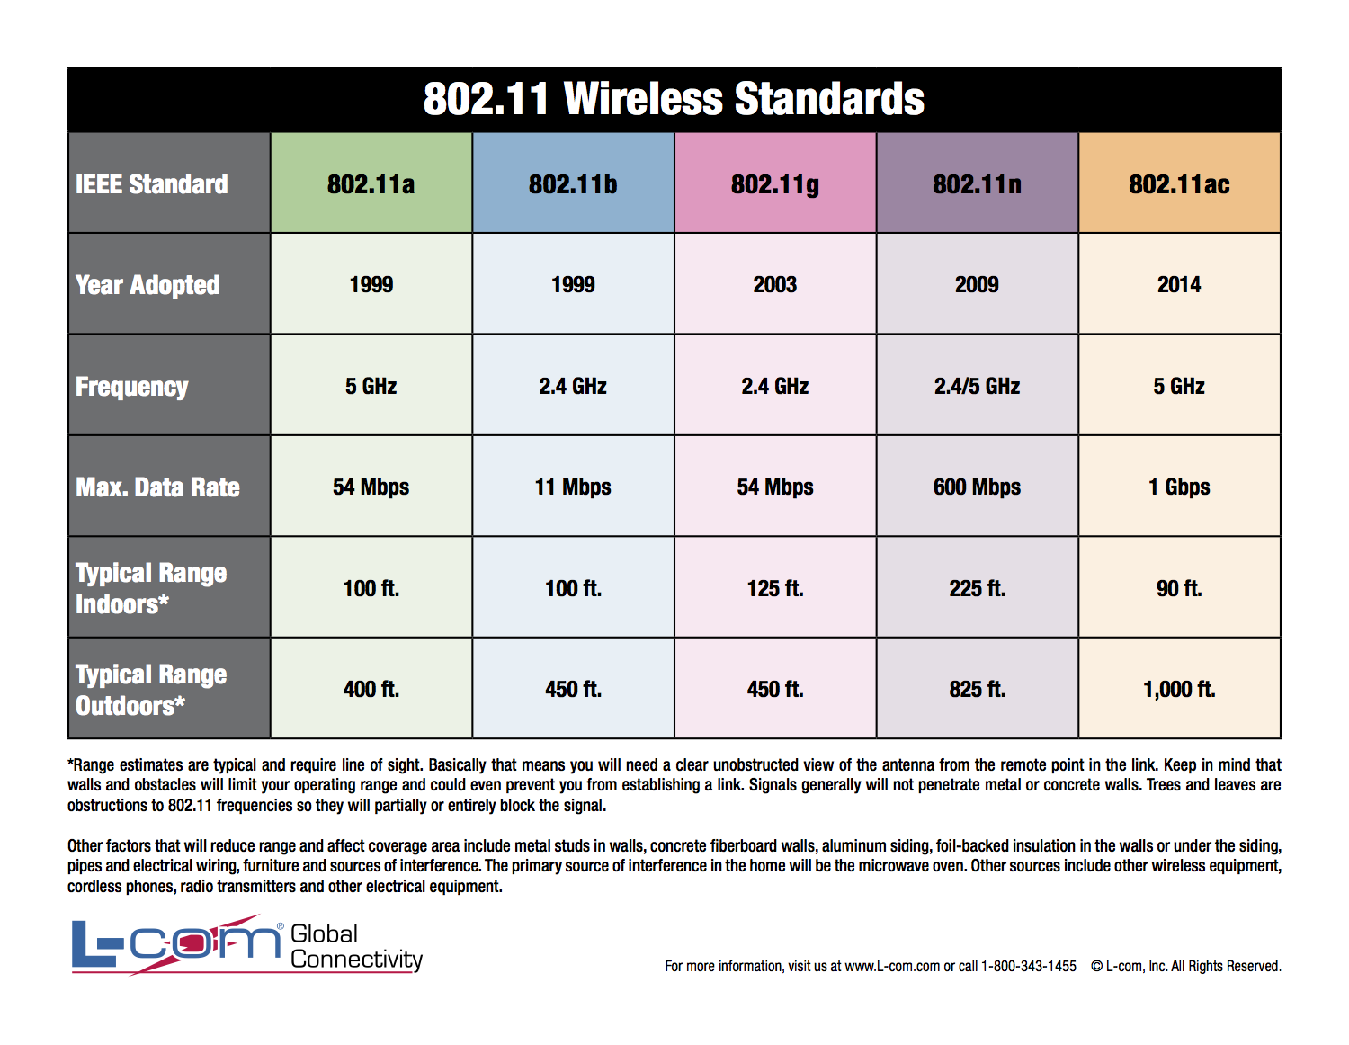

Wireless LAN Setup

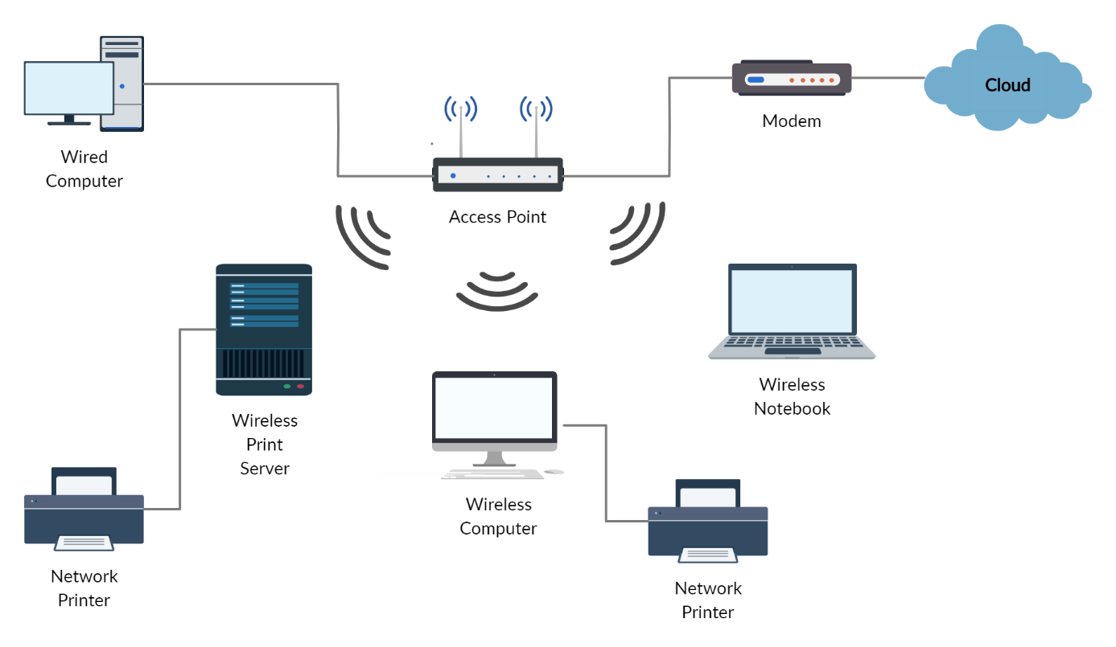

**Procedure :**

Steps to build a Wireless LAN –

1. Identify the equipment you want to buy, such as wireless notebooks, access points, Wireless LAN adapters and wireless cards.
2. Determine the number of users who need to have access to the network. This will help you determine the number of access points you’ll need.
3. Plan for the connection to your wired LAN, probably in a central location and in an open environment. Your goal is to maximize the access point’s wireless range. The quoted range is a maximum of 300 feet, but that’s very dependent on the existing environment – walls, water pipes, cables and so on, all could decrease the range. The best thing to do is complete a site survey first, if that’s not possible, assume a maximum range of 150 feet, as 300 could decrease throughput.
4. Configure your wireless devices to work with your network.
5. Test the installation before it goes live. Using link test software, you should test for the percent of data sent correctly, the time it takes to receive a response from the destination device, and the strength of the transmitted signal.
6. Establish a procedure to manage your Wireless LAN.

**Digital Communication Trainer System – SALICON ST8335 CDMA** Trainer provides a basic understanding of the concepts behind CDMA and various concepts needed to be considered in case of CDMA system design.



Features

* Self-contained and easy to use
* Functional blocks indicated on board mimic
* Direct Sequence Spread Spectrum (DSSS) generator and decoder
* Analog Modulators : Binary Phase Shift Keying (BPSK) Modulator & Pulse Width Modulator
* Analog Demodulators : Binary Phase Shift Keying (BPSK) Demodulator & Pulse Width Demodulator
* 2 Year Warranty

Scope of Learning

* To study theory of CDMA DSSS Modulation & Demodulation
* To generate CDMA-DSSS signal
* To demodulate CDMA-DSSS signal using BPSK
* To study pseudo random bit sequence generation

Technical Specifications

**Data Source**

Data Rate : 30 Kbps

Word Length : 8 bit

Data Format : NRZ (Non Return to Zero)

Clock Frequency : 30 KHz

**PN Sequence Generator**

Data Rate : 240 Kbps

Word Length : 15 bit

Data Format : NRZ (Non Return to Zero)

Clock Frequency : 240 KHz

Audio Signal Generator : 3.4 KHz (Variable Amplitude & Frequency)

Carrier Generators : 1.44 MHz (Sinusoidal)

DSSS Generator : By EX-ORing PN Code & Data

Modulators & Demodulators : PWM & BPSK

Interconnections : 2mm Socket

Mains Power Supply : 230V (10%), 50Hz

Power Consumption : 4 VA (Approximately)

Test Points : 40 nos.

Dimensions (mm) : W 420 x D 255 x H 100

Weight : 1 Kg. (Approximately)

Operating Conditions : 0-40 C, 85% RH

**Included Accessories**

2mm Patch Cord : 12 nos.

Mains Cord : 1 no.

Learning Material : 1 no. User Manual